<http://sitn.hms.harvard.edu/flash/2014/the-reason-for-the-season-why-flu-strikes-in-winter/>

“Did you get your flu shot?” If your friends are anything like mine, you heard this question at least a dozen times before Thanksgiving. You probably got your fair share of disdainful looks too, if you answered “No.” But why are we worried about getting the flu shot *now*and not in May? Why is there a flu season at all? After all, what does a virus living in a host who provides a dependable, cozy incubation chamber of 98°F, care whether it is freezing and snowy outside or warm and sunny? This question has bothered people for a long time, but only recently have we begun to understand the answer.

**What is the Flu?**

In order to discuss why we have a flu season, we must first understand what the flu is. The flu, also called influenza, is a viral respiratory illness. A virus is a microscopic infectious agent that invades the cells of your body and makes you sick. The flu is often confused with another virus, the common cold, because of the similarity in symptoms, which can include a cough, sore throat, and stuffy nose. However, flu symptoms also include fever, cold sweats, aches throughout the body, headache, exhaustion, and even some gastro-intestinal symptoms, such as vomiting and diarrhea (1).

The flu is highly contagious. Adults are able to spread the virus one day prior to the appearance of symptoms and up to seven days after symptoms begin. Influenza is typically spread via the coughs and sneezes of an infected person (1). Around 200,000 people in the United States are hospitalized each year because of the flu, and of these people, about 36,000 die.  The flu is most serious for the elderly, the very young, or people who have a weakened immune system (1).

**The Flu Season**

The flu season in the U.S. can begin as early as October, but usually does not get into full swing until December. The season generally reaches its peak in February and ends in March (2). In the southern hemisphere, however, where winter comes during our summer months, the flu season falls between June and September. In other words, wherever there is winter, there is flu (3). In fact, even its name, “influenza” may be a reference to its original Italian name, *influenza di freddo*, meaning “influence of the cold” (4).

A common misconception is that the flu is caused by cold temperatures. However, the influenza virus is necessary to have the flu, so cold temperatures can only be a contributing factor. In fact, some people have argued that it is not cold temperatures that make the flu more common in the winter. Rather, they attest that the lack of sunlight or the different lifestyles people lead in winter months are the primary contributing factors. Here are the most popular theories about why the flu strikes in winter:

1) During the winter, people spend more time indoors with the windows sealed, so they are more likely to breathe the same air as someone who has the flu and thus contract the virus (3).

2) Days are shorter during the winter, and lack of sunlight leads to  low levels of vitamin D and melatonin, both of which require sunlight for their generation. This compromises our immune systems, which in turn decreases ability to fight the virus (3).

3) The influenza virus may survive better in colder, drier climates, and therefore be able to infect more people (3).

**The Flu Likes Cold, Dry Weather**

For many years, it was impossible to test these hypotheses, since most lab animals do not catch the flu like humans do, and using humans as test subjects for this sort of thing is generally frowned upon. Around 2007, however, a researcher named Dr. Peter Palese found a peculiar comment in an old paper published after the 1918 flu pandemic: the author of the 1919 paper stated that upon the arrival of the flu virus to Camp Cody in New Mexico, the guinea pigs in the lab began to get sick and die (4). Palese tried infecting a few guinea pigs with influenza, and sure enough, the guinea pigs got sick. Importantly, not only did the guinea pigs exhibit flu symptoms when they were inoculated by Palese, but the virus was transmitted from one guinea pig to another (4).

Now that Palese had a model organism, he was able to begin experiments to get to the bottom of the flu season. He decided to first test whether or not the flu is transmitted better in a cold, dry climate than a warm, humid one. To test this, Palese infected batches of guinea pigs and placed them in cages adjacent to uninfected guinea pigs to allow the virus to spread from one cage to the other. The pairs of guinea pig cages were kept at varying temperatures (41°F, 68°F, and 86°F) and humidity (20%-80%). Palese found that the virus was transmitted better at low temperatures and low humidity than at high temperatures and high humidity (see Figure 1).

[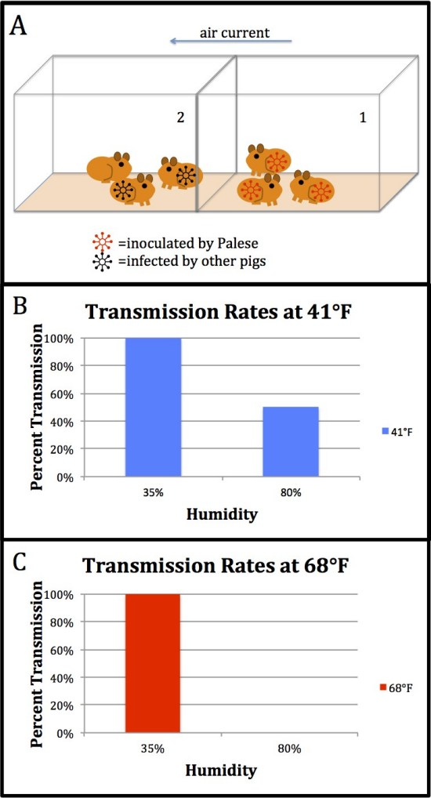](https://i1.wp.com/sitn.hms.harvard.edu/wp-content/uploads/2014/11/guinea-pig-figure2.jpg)

***Figure 1****~ Experimental Setup. Guinea pigs were housed in adjacent cages. Guinea pigs in cage 1 were infected by Palese with influenza. Palese observed how many guinea pigs in cage 2 became infected from the guinea pigs in cage 1 at different temperatures and levels of humidity. B, C) Transmission rates were 100% at low humidity, regardless of temperature. At high humidity, transmission occurred only at the lower temperature.*

However, Palese’s initial experiment did not explain *why* the virus was transmitted best at cooler temperatures and low humidity. Palese tested the immune systems of the animals to find out if the immune system functions poorly at low temperatures and low humidity, but he found no difference in innate immunity among the guinea pigs (5). A paper from the 1960s may provide an alternate explanation. The study tested the survival time of different viruses (*i.e.* the amount of time the virus remains viable and capable of causing disease) at contrasting temperatures and levels of humidity. The results from the study suggest that influenza actually survives longer at low humidity and low temperatures. At 43°F with very low humidity, most of the virus was able to survive more than 23 hours, whereas at high humidity and a temperature of 90°F, survival was diminished at even one hour into incubation (3).

The data from these studies are supported by a third study that reports higher numbers of flu infections the month after a very dry period (6). In case you’re wondering, this is only the case in places that experience winter. In warmer climates, oddly enough, flu infection rates are correlated most closely with high humidity and lots of rain (6). Unfortunately, not much research has been done to explain these contradictory results, so it’s unclear why the flu behaves so differently in disparate environments. This emphasizes the need for continued influenza research. Therefore, we can conclude that, at least in regions that have a winter season, the influenza virus survives longer in cold, dry air, so it has a greater chance of infecting another person.

Although other factors probably contribute as well, the main reason we have a flu season may simply be that the influenza virus is happier in cold, dry weather and thus better able to invade our bodies. So, as the temperature and humidity keep dropping, your best bet for warding off this nasty bug is to get your flu shot ASAP, stay warm, and invest in a humidifier.

Hannah Foster is a PhD candidate in the Molecules, Cells, and Organisms program at Harvard University.

For more information about the flu, check out this video:

#### References

1) Medical News Today. What is flu? What is influenza? What are the symptoms of flu? < >[2 November, 2014]

2) Centers for Disease Control. The Flu Season. <<http://www.cdc.gov/flu/about/season/flu-season.htm>> [2 November, 2014]

3) Elert, E. 2013. FYI: Why is There a Winter Flu Season? Popular Science.  <<http://www.popsci.com/science/article/2013-01/fyi-why-winter-flu-season>> [2 November, 2014]

4) Kolata, G. 2007. Study Shows Why the Flu Likes Winter. New York Times.<<http://www.nytimes.com/2007/12/05/health/research/05flu.html?_r=1&>> [2 November, 2014]

# **Study Shows Why the Flu Likes Winter**

Researchers in New York believe they have solved one of the great mysteries of [the flu](http://health.nytimes.com/health/guides/disease/the-flu/overview.html?inline=nyt-classifier): Why does the infection spread primarily in the winter months?

The answer, they say, has to do with the virus itself. It is more stable and stays in the air longer when air is cold and dry, the exact conditions for much of the flu season.

“Influenza virus is more likely to be transmitted during winter on the way to the subway than in a warm room,” said Peter Palese, a [flu](http://health.nytimes.com/health/guides/disease/the-flu/overview.html?inline=nyt-classifier) researcher who is professor and chairman of the microbiology department at Mount Sinai School of Medicine in New York and the lead author of the flu study.

Dr. Palese published details of his findings in the Oct. 19 issue of PLoS Pathogens. The crucial hint that allowed him to do his study came from a paper published in the aftermath of the 1918 flu pandemic, when doctors were puzzling over why and how the virus had spread so quickly and been so deadly.

As long as flu has been recognized, people have asked, Why winter? The very name, “influenza,” is an Italian word that some historians proposed, originated in the mid-18th century as influenza di freddo, or “influence of the cold.”

[Continue reading the main story](https://www.nytimes.com/2007/12/05/health/research/05flu.html?_r=1&#story-continues-2)

## RELATED COVERAGE

Flu season in northern latitudes is from November to March, the coldest months. In southern latitudes, it is from May until September. In the tropics, there is not much flu at all and no real flu season.

There was no shortage of hypotheses. Some said flu came in winter because people are indoors; and children are in school, crowded together, getting the flu and passing it on to their families.

Others proposed a diminished [immune response](http://health.nytimes.com/health/guides/specialtopic/immune-response/overview.html?inline=nyt-classifier) because people make less [vitamin D](http://health.nytimes.com/health/guides/nutrition/vitamin-d/overview.html?inline=nyt-classifier) or melatonin when days are shorter. Others pointed to the direction of air currents in the upper atmosphere. But many scientists were not convinced.

“We know one of the largest factors is kids in school — most of the major epidemics are traced to children,” said Dr. Jonathan McCullers, a flu researcher at St. Jude Children’s Research Hospital in Memphis. “But that still does not explain wintertime. We don’t see flu in September and October.”

As for the crowding argument, Dr. McCullers said, “That never made sense.” People work all year round and crowd into buses and subways and planes no matter what the season.

“We needed some actual data,” Dr. McCullers added.

But getting data was surprisingly difficult, Dr. Palese said.

The ideal study would expose people to the virus under different conditions and ask how likely they were to become infected. Such a study, Dr. Palese said, would not be permitted because there would be no benefit to the individuals.

There were no suitable test animals. Mice can be infected with the influenza virus but do not transmit it. Ferrets can be infected and transmit the virus, but they are somewhat large, they bite and they are expensive, so researchers would rather not work with them.

To his surprise, Dr. Palese stumbled upon a solution that appeared to be a good second best.

Reading a paper published in 1919 in the Journal of the American Medical Association on the flu epidemic at Camp Cody in New Mexico, he came upon a key passage: “It is interesting to note that very soon after the epidemic of influenza reached this camp, our laboratory guinea pigs began to die.” At first, the study’s authors wrote, they thought the animals had died from [food poisoning](http://health.nytimes.com/health/guides/disease/campylobacter-enteritis/overview.html?inline=nyt-classifier). But, they continued, “a necropsy on a dead pig revealed unmistakable signs of [pneumonia](http://health.nytimes.com/health/guides/disease/pneumonia/overview.html?inline=nyt-classifier).”

Dr. Palese bought some guinea pigs and exposed them to the flu virus. Just as the paper suggested, they got the flu and spread it among themselves. So Dr. Palese and his colleagues began their experiments.

By varying air temperature and humidity in the guinea pigs’ quarters, they discovered that transmission was excellent at 41 degrees. It declined as the temperature rose until, by 86 degrees, the virus was not transmitted at all.

The virus was transmitted best at a low humidity, 20 percent, and not transmitted at all when the humidity reached 80 percent.

The animals also released viruses nearly two days longer at 41 degrees than at a typical room temperature of 68 degrees.

Flu viruses spread through the air, unlike cold viruses, Dr. Palese said, which primarily spread by direct contact when people touch surfaces that had been touched by someone with a cold or shake hands with someone who is infected, for example.

Flu viruses are more stable in cold air, and low humidity also helps the virus particles remain in the air. That is because the viruses float in the air in little respiratory droplets, Dr. Palese said. When the air is humid, those droplets pick up water, grow larger and fall to the ground.

But Dr. Palese does not suggest staying in a greenhouse all winter to avoid the flu. The best strategy, he says, is a [flu shot](http://health.nytimes.com/health/guides/specialtopic/influenza-vaccine/overview.html?inline=nyt-classifier).

It is unclear why infected animals released viruses for a longer time at lower temperatures. There was no difference in their immune response, but one possibility is that their upper airways are cooler, making the virus residing there more stable.

Flu researchers said they were delighted to get some solid data at last on flu seasonality.

“It was great work, and work that needed to be done,” said Dr. Terrence Tumpe, a senior microbiologist at the Centers for Disease Control and Prevention.

Dr. McCullers said he was pleased to see something convincing on the flu season question.

“It was a really interesting paper, the first really scientific approach, to answer a classic question that we’ve been debating for years and years,” he said.

As for Dr. Palese, he was glad he spotted the journal article that mentioned guinea pigs.

“Sometimes it pays to read the old literature,” he said.

5) Lowen, A.C., S. Mubareka, J. Steel, and P. Palese. 2007. Influenza Virus Transmission Is Dependent on Relative Humidity and Temperature. PLOS Pathogens. 3(10):e151.

6) Roos, R. 2013. Study: Flu likes weather cold and dry or humid and rainy. University of Minnesota Center for Infectious Disease Research and Policy.<<http://www.cidrap.umn.edu/news-perspective/2013/03/study-flu-likes-weather-cold-and-dry-or-humid-and-rainy>> [14 November, 2014]